Algorithms

**INTRODUCTION TO ASYMPTOTIC NOTATION**

There will be many solutions to a given problem each of which will be given by an algorithm. Now, we want that algorithm which is going to give me the result quickest while consuming not much of the space (memory). Therefore, design and analysis of algorithms is the subject to design the various algorithms for a problem and analyze them for the best possible algorithm to choose.

Before proceeding, we have some notations to understand. These are called asymptotic notations.

Let’s say we have a function f(n) and as the n increases the rate of growth of time increases in a certain way.



1. **Big-Oh (O)**: Let’s find another function ‘cg(n)’ (above graph) in such a way that the after it gets an input n0 the value of this function is always greater than the f(n). Then if:

$$f\left(n\right)≤cg\left(n\right)$$

$$n≥n_{0}$$

$$c>0,n≥1$$

If the above satisfies, then we can say that

$$f\left(n\right)=O\left(g\left(n\right)\right)$$

Which is equivalent to say that f(n) is smaller than g(n).

Let’s take an example: f(n) = 3n + 2 and g(n) = n, is f(n) = O(g(n))?

Note: The tightest bound here is ‘n’. If f(n) = O(g(n)) then definitely n2, n3… will be upper bounds, but we need to see the tightest bound which is ‘n’ in this case.



1. **Big-Omega(Ω)** :



Let’s find another function ‘cg(n)’ (above graph) in such a way that the after it gets an input n0 the value of this function is always smaller than the f(n). Then if:

$$f\left(n\right)≥cg\left(n\right)$$

$$n≥n_{0}$$

$$c>0,n≥1$$

If the above satisfies, then we can say that

$$f\left(n\right)=Ω\left(g\left(n\right)\right)$$

Which is equivalent to say that f(n) is greater than g(n).

*We will see examples about it.*

1. **Big-Theta(Θ):** We say that a function f(n) = Θ(g(n)), if the function f(n) is bounded by both lower and upper bounds. Let’s see the graph for same.



Therefore,

$$c_{1}g\left(n\right)≤f\left(n\right)≤C_{2}g\left(n\right)$$

$$C_{1},C_{2}>0$$

$$n≥n_{0}, n_{0}≥1$$

If the above is satisfied then we can say f(n) = Θ(g(n))

Example: f(n) = 3n + 2, g(n) = n. Is f(n) = Θ(g(n))?



**Practical significance of the symbols:**

Given any algorithm:

* O is going to say “worst case time” or the “upper bound”. In other words, if you are giving time complexity in O notation, that will mean “In any case the time will not exceed this”.
* Ω is going to say “best case time” which means in any case you can never achieve better than this.
* Θ is giving you the average case

In practicality we worry about the question “What is the worst case time the algorithm will take for any input?”

For some algorithms, the best and worst case will be same. In those scenarios we go for Θ.

We have seen that an algorithm’s time complexity is given as a function f(n). This function is an *approximation* of the time taken by the algorithm and NOT the actual time it may take. Now let’s see how to find f(n) which means *what is the approximate time taken by the algorithm.* Before we go into that let’s understand more about algorithms.

There are two types of algorithms:

1. Iterative
2. Recursive

* It is worth noting that *any program that can be written using iteration can be written using recursion and vice versa.* Therefore, both are equivalent in power.
* For iterative program, you count the number of times the loop is going to get executed to find the time it’s going to take. To find the time taken by a recursive program we use recursive equations. This means that they are both same in power but their analysis methods are different.
* ***In case if the algorithm does not contain either iteration or recursion it means that there is no dependency of the running time on the input size which means whatever is the size of the input the running time will be a constant value.***

Let’s see some of the iterative programs and how to do complexity analysis of them.

**COMPLEXITY ANALYSIS OF ITERATIVE PROGRAMS**

Example 1: Do the complexity analysis of the following program.



Le ‘k’ be the value that ‘s’ takes before the loop stops.

With each loop:

i=1, 2, 3, 4, … k

s = 1, 3, 6, 10, … n

We see that for every increase in ‘i’ s is the sum of first ‘i’ natural numbers. Therefore at when the loop reaches k to halt:

K(k+1)/2 > n

(K2 + k)/2 > n

* K = O()



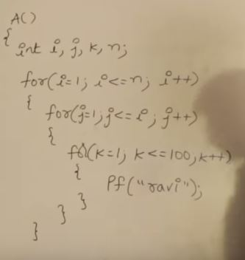



|  |  |  |  |  |  |  |
| --- | --- | --- | --- | --- | --- | --- |
| I | 1 | 2 | 3 | 4 | … | N |
| J (times) | 1 | 2 | 3 | 4 | … | N |
| K(times) | 1x100 | 2x100 | 3x100 | 4x100 | … | Nx100 |

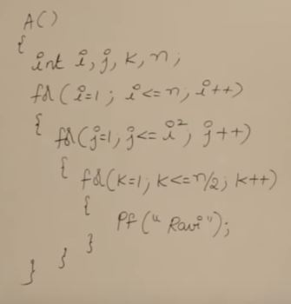



|  |  |  |  |  |  |  |
| --- | --- | --- | --- | --- | --- | --- |
| I | 1 | 2 | 3 | 4 | … | N |
| J(times exec) | 1 | 2 | 9 | 16 | … | N2 |
| K(times exec) | (N /2)x1 | (N /2)x2 | (N /2)x9 | (N /2)x16 | … | (N/2)*N2 |

**F(n) = nk + nk-1 + nk-2… = O(nk)**



If i was increasing at the rate of 3, 4, 5, 6, instead of 2 in above example:

Then: for I = I * 2 : O(log2n)

I = I * 3 : O(log3n) Therefore, for I = I *m complexity will be **O(logmn)**

I = I * 4 : O(log4n)

I = I * 5 : O(log5n)

Let’s see an example depending on this example.

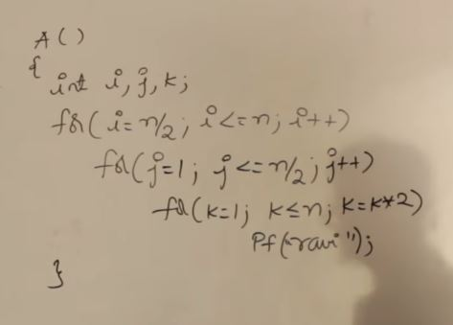



We don’t need to unroll the loops in this example because every loop’s conditional statement is independent of the variable of the other loops.



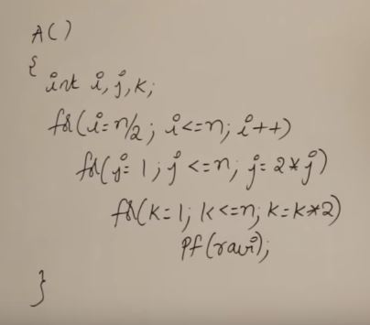



In this example also the loops are independent of other loops’ variables. So, no need to unroll them.



**For question 9 above, if n was updating like:**



**N = n/5 then the complexity would be O(log5n)**



**N = n/m then the complexity would be O(logmn)**



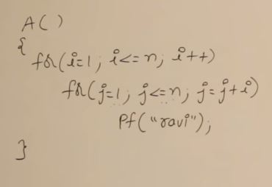



The inner loop is dependent on the variable of the outer loop. In this example we will have to unroll the loops to see wassup!

|  |  |  |  |  |  |  |  |
| --- | --- | --- | --- | --- | --- | --- | --- |
| For I equals to | 1 | 2 | 3 | 4 | … | K | N |
| J will execute | 1 to N | 1 to N | 1 to N | 1 to N | … | 1 to N | 1 to N |
| J will execute times | N times | N/2 times | N/3 times | N/4 times | … | N/K times | N/N times |



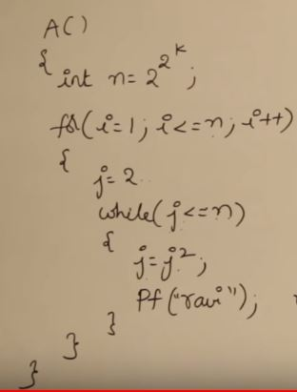



|  |  |  |  |  |
| --- | --- | --- | --- | --- |
| At K | 1 | 2 | 3 | K |
| N will be | 4 | 16 | 28 | 2K |
| J values after each loop | 2, 4 | 2, 4, 16 | 2, 4, 16, 256 | 2, 4, 16, …, 2K |
| While will execute | N x 2 times | N x 3 times | N x 4 times | N x (K+1) times |